**Sales Performance Analysis of Blink it Using Python-Based Data Analytics**



Prepared by ILAYA BARATHI M

# Abstract

This study explores the sales performance of Blinkit through quantitative data analytics using Python. The objective is to identify patterns in customer behavior, sales distribution, and product performance by analyzing structured sales data. Using multiple KPIs and visualizations, we examine the relationship between sales metrics and factors such as fat content, item type, and retail outlet performance. The findings offer strategic insights for optimizing inventory, improving customer satisfaction, and enhancing business efficiency.

# 1. Introduction

In the highly competitive e-grocery market, understanding sales dynamics is crucial for driving operational decisions. Blinkit, a fast-paced grocery delivery service, faces challenges in aligning inventory with customer demand and maximizing revenue across diverse products. This study utilizes data analytics techniques to extract actionable insights from Blinkit’s historical sales data, focusing on product types, nutritional profiles, and outlet-level distribution.

# 2. Methodology

**2.1 Data Source**  
The dataset comprises Blinkit’s sales data, including product details (item type, fat content), transactional records, and customer ratings.

**2.2 Tools and Technologies**  
The analysis was conducted using Python and relevant libraries:  
- Pandas for data manipulation,  
- Matplotlib and Seaborn for static plotting,  
- Plotly for interactive visualizations.

# 

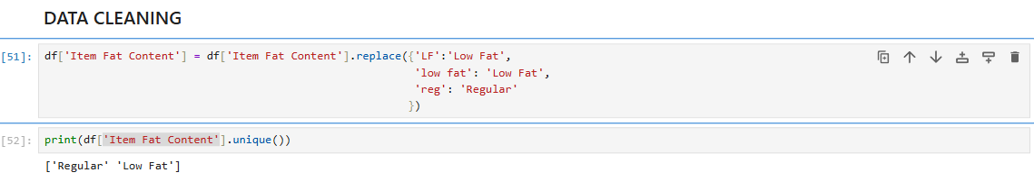

# 3. Key Performance Indicators (KPIs)

The following KPIs were computed to assess the performance metrics:  
- Total Sales: Aggregate revenue from all transactions.  
- Average Sales: Mean revenue per sale.  
- Number of Items Sold: Quantity and diversity of products sold.  
- Average Rating: Mean customer satisfaction score per item.

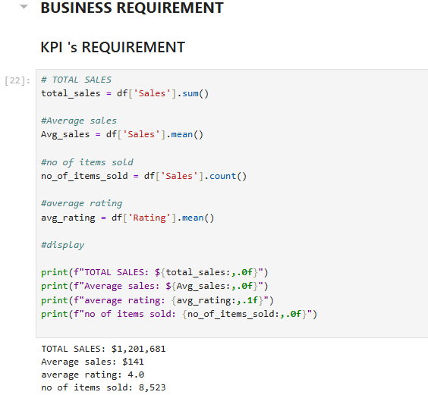

# 4. Analysis and Results

**4.1 Sales by Fat Content**  
A donut chart visualization revealed that high-fat content items generated higher total sales. Notably, they also exhibited higher average ratings, indicating a preference pattern among consumers.

**Objective:** Analyze the impact of fat content on total sales.

Additional KPI Metrics: Assess how other KPIs (Average Sales, Number of Items, Average Rating) vary with fat content.

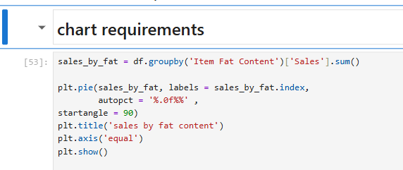

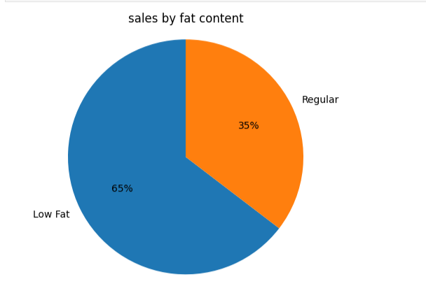

**4.2 Sales by Item Type**Using a bar chart, we analyzed total sales across item types. Dairy products and frozen goods emerged as high performers in terms of both volume and customer satisfaction.

**Objective**: Identify the performance of different item types in terms of total sales.

Additional KPI Metrics: Assess how other KPIs (Average Sales, Number of Items, Average Rating) vary with fat content.

Chart Type: Bar Chart

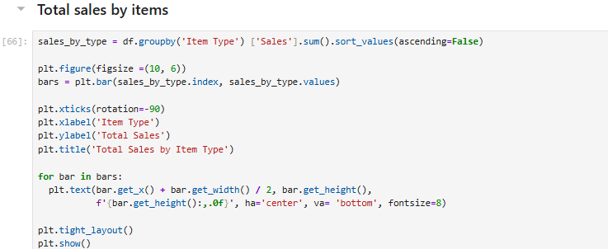

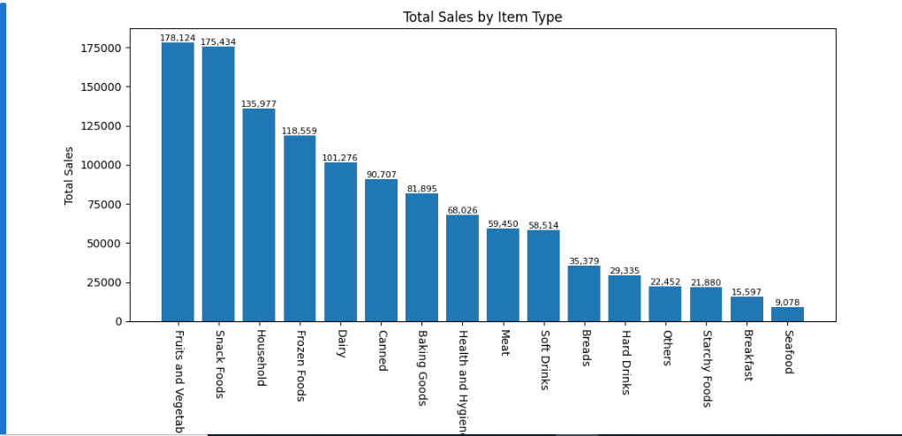

**4.3 Fat Content vs. Outlet-Level Sales**

A stacked column chart was utilized to compare total sales segmented by fat content across different retail outlets. This revealed that outlets with a higher stock of full-fat products showed stronger sales performance, suggesting localized consumer preferences.

**Objective**: Compare total sales across different outlets segmented by fat content.

Additional KPI Metrics: Assess how other KPIs (Average Sales, Number of Items, Average Rating) vary with fat content.

Chart Type: Stacked Column Chart

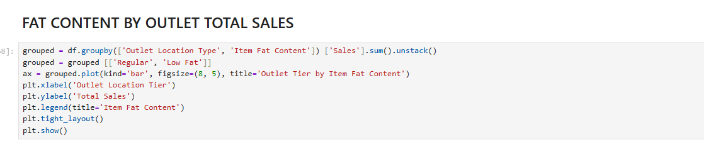

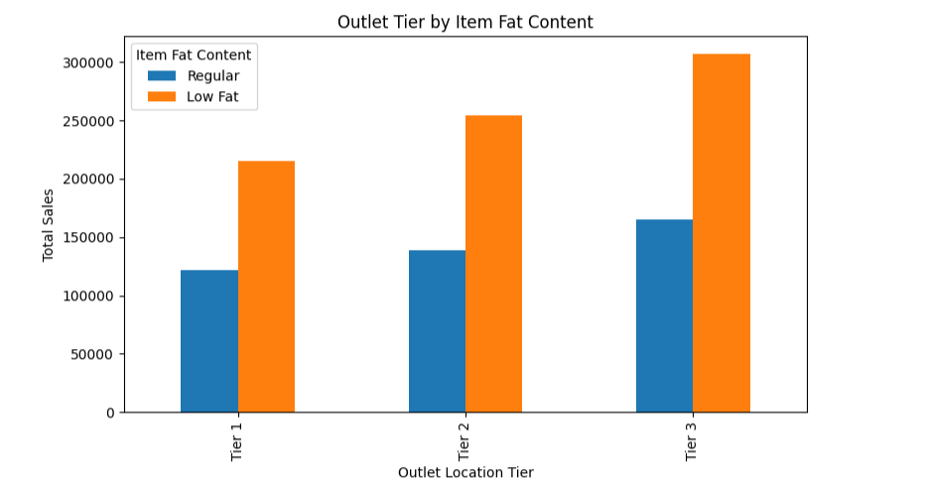

# 5. Discussion

The results highlight the impact of nutritional composition on sales dynamics. Items with higher fat content tend to perform better, possibly due to taste preferences or marketing strategies. Moreover, outlet-level analysis suggests the need for region-specific stocking strategies. These insights can inform inventory planning and promotional campaigns.

# 6. Conclusion

This research confirms that data-driven insights can significantly enhance sales strategies. By leveraging Python for analytics and visualization, businesses like Blinkit can optimize inventory, tailor marketing efforts, and enhance overall customer satisfaction.

# 7. Future Work

Further research may include time-series forecasting for demand prediction, sentiment analysis from customer reviews, and integration with real-time data to enable dynamic pricing and inventory updates.